Sunday, June 17 and Wednesday, June 20 + 4th Sunday after Pentecost

Mark 4:26-34

Holy Trinity Lutheran Church, Marshall, WI

Rev. Nancy M Raabe

More about Holy Trinity

More about Pastor Nancy Raabe

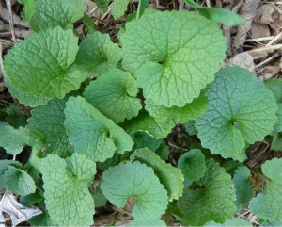
I never thought garlic mustard would be good for anything. Then I discovered it’s an edible plant—in fact, there is a recipe for Garlic Mustard Pesto on the Welcome Desk if you’d like to try it out. But most of us view garlic mustard with suspicion it as one of our most invasive non-native plant species. Especially in wooded areas it wants to take over everything, much as kudzu does in the South. I never noticed it in Ohio, but when we moved to Wisconsin I quickly identified garlic mustard as my Number One Garden Enemy. First it appears as this, then as this, and before you know it you can say goodbye to whatever biodiversity there might have been on the forest floor. But the above Mark reading has given me an entirely new perspective on this prolific weed.

As you know, many of Jesus’ parables are shared among the three Synoptic gospels – Matthew, Mark and Luke – and a few of the more colorful ones even turn up in John. But the parable of the mustard seed appears only in Mark. Why? Maybe because it’s boring. After all, nothing happens. There are no dramatic healings, no strange questions, no startling answers, no surprising turn of events. Mark was the first gospel to be written, so none of the others must have thought it was worth including.

But context is everything. Here, the context in which Jesus is speaking is clearly that of Ezekiel 17. Remember how, in that reading, God tells us that he can take a tiny sprig from the top of a cedar tree, plant it on top of a high mountain, and that little bud will grow into a huge cedar whose boughs can shelter every kind of birds on earth? “I the Lord can accomplish anything,” God is saying through Ezekiel. Something small will become large and grand; something insignificant will become noble. We might think of the ancient proverb, “Mighty oaks from little acorns grow.”

But this isn’t what Jesus is saying. Jesus’ parables are illustrations of God’s reign on earth, one that reverses of the way the world has been working. The parables proclaim an entirely new order, one not ruled autocratically by oppression and wealth and intimidation, but by love, the force that gives and sustains life. Each of Jesus’ parables tells us something revelatory about God’s kingdom.

So what do we notice in the humble parable of the mustard seed?

There are a few clues. First, is a mustard seed really the smallest of all? Actually, there are many smaller seeds Jesus could have used if smallness is all he was intending to show.

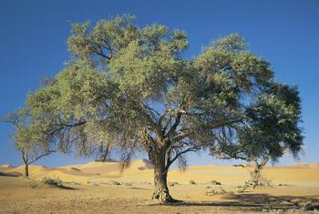
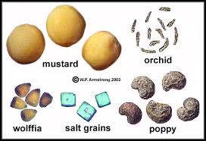
Second, does a mustard seed grow into the greatest of all trees, as Jesus sets us up to expect he will say, on the model of the Ezekiel passage? His disciples, to whom he’s talking, are probably taken by surprise—they expected the example of the mighty cedar, not a homely shrub.

Why then a mustard seed? Jesus could have compared God’s reign to the cedars of Lebanon if he wanted to describe a new world order that would cause people to drop everything and be impressed, as in Ezekiel. Instead he describes something more ordinary, and yet also something more able to show up, to take over inch by inch, and eventually to transform the entire landscape. I think Jesus is talking about garlic mustard.

Now listen again to the first part of the Mark reading above.

The kingdom of God is as if someone would scatter seed on the ground, ²⁷ and would sleep and rise night and day, and the seed would sprout and grow, he does not know how. ²⁸ The earth produces of itself, first the stalk, then the head, then the full grain in the head.

Two things. First, God’s in-breaking kingdom messes with convention. All of Jesus’ parables illustrate the up-ending of expectations of a world governed from the top down by power systems and institutions. God is at work not in dictators or autocrats but in humble ways, in hidden places, in people that you would never expect to be prophets who spread the message of love and forgiveness from one heart to another.
Many of us consider garlic mustard to be our enemy. Yet here, I think it is lifted up as a metaphor for the reign of God and the mission of the church. God’s kingdom is fast-replicating plant that will get into everything. It will bring life and color to desolate places. It will crowd out other concerns. It will resist our best efforts to destroy it. Its humble appearance will expose pride and pretentiousness.
As a result, some people will want to burn it all down in a pointless attempt to restore things to the way they were before. But their efforts will be fruitless and will only bring about their own ruin. You can’t stop garlic mustard from taking over, and you can’t stop God’s reign from breaking in.
Second, God’s kingdom will come about whether we do anything or not. In the same way that faith grows in each of us, God’s kingdom will grow gradually and automatically by the life forces that God set in motion. This is why congregations that throw all their eggs into the basket of programming are missing the boat. I think the ELCA’s tagline, “God’s Work, Our Hands,” reinforces this workaholic mentality. People are generally trying hard, too hard, to carry out programs that make them feel as if they are serving God, and are often burning themselves out in the process.
Instead, we are better served by paying attention to signs of God’s grace around us. Be on the alert for each new leaf or tender shoot that bursts forth. Recognize these as signs of the Holy Spirit. Each one, however small, represents the coming reign of God and the breaking down of systems of dominance and servitude. God’s kingdom is replacing those systems—covering them over, crowding them out out—by the triumph of love over hate, good over evil, compassion over apathy, attentiveness over neglect.
Because our faith is growing in us even without us realizing it, we are naturally moved to acts of love and compassion. Let the work of your hands be a product of God’s love. Just as garlic mustard provides nutrients for a healthy body, so love, faith and hope provide what is needed for a healthy congregation, one that is a mirror of God’s in-breaking kingdom. Let’s grow together in faith, hope, and love.

